Installing Python:

Step 1) To download and install Python visit the official website of Python https://www.python.org/downloads/release/python-376/.

We have chosen Python version 3.7.6.Click -> Windows x86-64 executable installer.

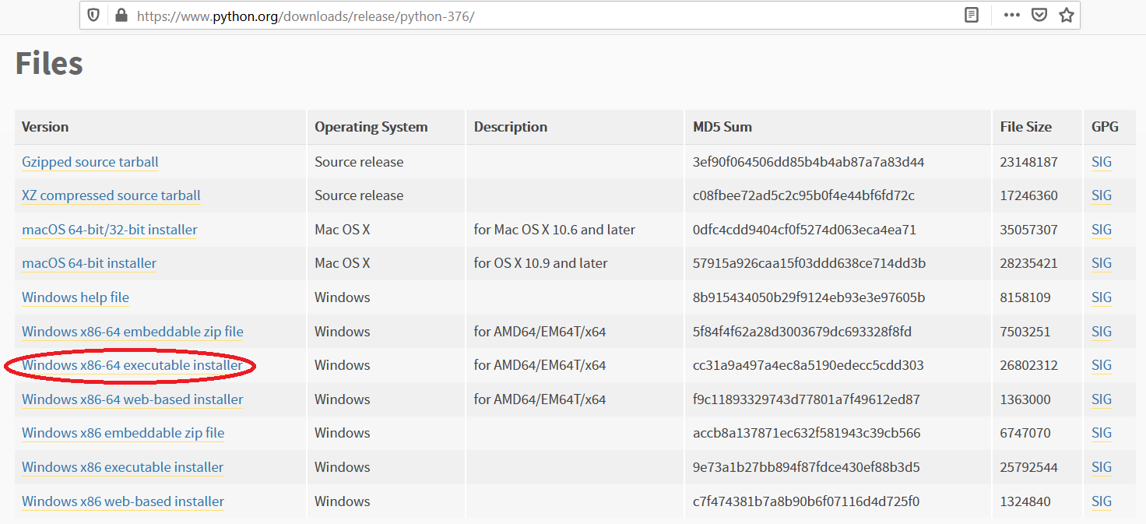
Step 2) Once the download is complete, run the exe for install Python. Please select “Add Python 3.7 to PATH”. Now click on Install Now.
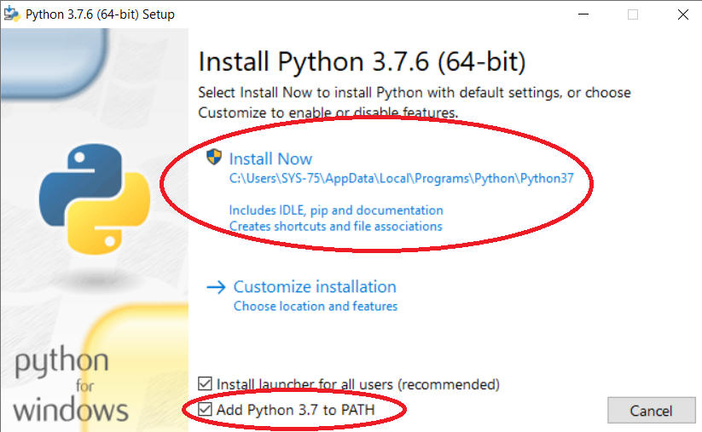
Step 3) You can see Python installing at this point.
Step 4) When it finishes, you can see a screen that says the Setup was successful. Now click on "Close".

Installing Pycharm:

Step 1) To download PyCharm visit the website https://www.jetbrains.com/pycharm/download/other.html.

select Version: 2020.3.3

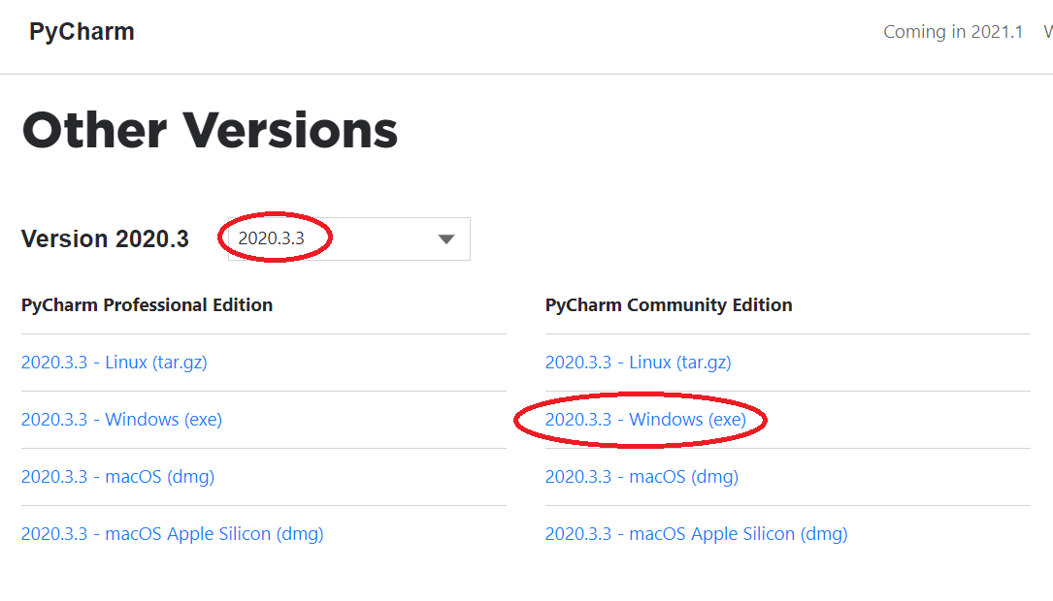

Step 2) Once the download is complete, run the exe for install PyCharm. The setup wizard should have started. Click “Next”.

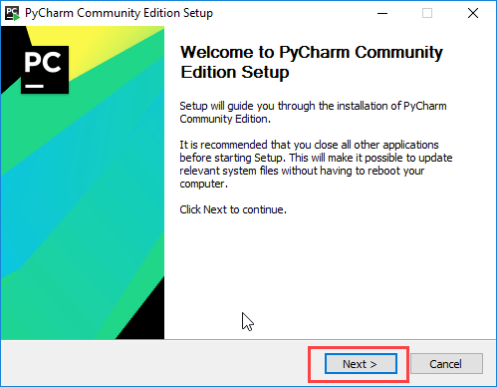

Step 3) On the next screen, Change the installation path if required. Click “Next”.

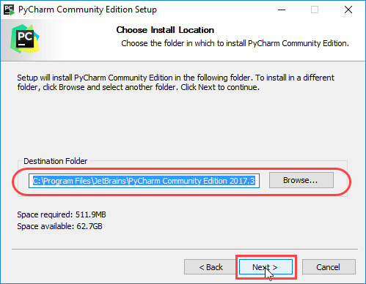

Step 4) On the next screen, you can create a desktop shortcut if you want and click on “Next”.
Step 5) Choose the start menu folder. Keep selected JetBrains and click on “Install”.
Step 6) Wait for the installation to finish.
Step 7) Once installation finished, you should receive a message screen that PyCharm is installed. If you want to go ahead and run it, click the “Run PyCharm Community Edition” box first and click “Finish”.
Step 8) After you click on "Finish," the Following screen will appear.
